Assignment 0:

Subject: Photo/recording high-altitude balloon

Names:

Zafrir Yakir 203715602

Itzik Asyag: 305045312

Liz Hadida: 302839667

Oz Levi: 305181158

General Overview: The general idea of this project is a helium balloon rising high up in the air with software that allows us to capture photos/videos of the ground and enables us to save them.

* Illustrative video: <https://www.youtube.com/watch?v=GVCi4T2FLw8>

Software requirements specifications:

1. Hardware: smartphone with camera, android app support and an internet connection.
2. Software: allows us to capture photos/videos and save them.
3. Tools: high-altitude balloon, helium gas, Styrofoam box.

* We will inflate a high-altitude balloon via helium gas to make it fly in the air. For safety reasons, we will put the smartphone in a Styrofoam box.

Possible issues:

1. Poor signal quality: after the balloon reaches a certain height, the signal weakens significantly and can even stop completely, which can cause a total disconnection from the internet.
2. Weather conditions: winds, rain, thunder storms- all of which can harm the balloon and the smartphone.
3. Crash: possible collision with foreign objects or gas-leak.
4. Safety: In case it does crash, the fall of the device to the ground can reach a high velocity and cause harm to its surrounding environment (people, objects, etc.)

Solutions:

1. Styrofoam box: we can insert the smartphone device into a Styrofoam box in case the balloon crashes (could be for multiple reasons as described above) from high up. This way we can prevent harming the surrounding environment.
2. Check weather beforehand to prevent any accidents.

Comparison table:

|  |  |  |  |  |
| --- | --- | --- | --- | --- |
| App/Open Source: Characteristics | Google photos App | IP Web Camera  App | Picasa Mobile  App | Open Camera  (Open-source) |
| Photography | X | V | V | V |
| Timed photography | X | X | X | V |
| Video | X | V | X | V |
| Automatic Save | V | X | V | X |
| GPS | V | X | V | V |
| 3G | V | X | V | V |
| Wi-Fi | V | V | V | V |
| Remote Control | X | V | X | X |

Choosing open-source tool:

We chose open camera mainly because it is user-friendly and has great features that make it easy to use as well as improve photo/video quality.

This app allows you to photograph and take videos with the help of “timer” and “burst”. The timer allows you to choose how many seconds it will take the app to take a picture after you capture a photo. The burst option allows you to take multiple photos in succession (you can add a delay in-between taking photos. There is a cool option to auto-stabilize so your pictures are perfectly level no matter what (really good if you’re in the air! ;)).

One disadvantage of this app is the fact you cannot synchronize your photos/videos to a folder or a certain cloud. To solve this issue, we used Google Photos App to automatically sync from an android folder.

Here are screenshots using Open Camera:

Capture

Settings

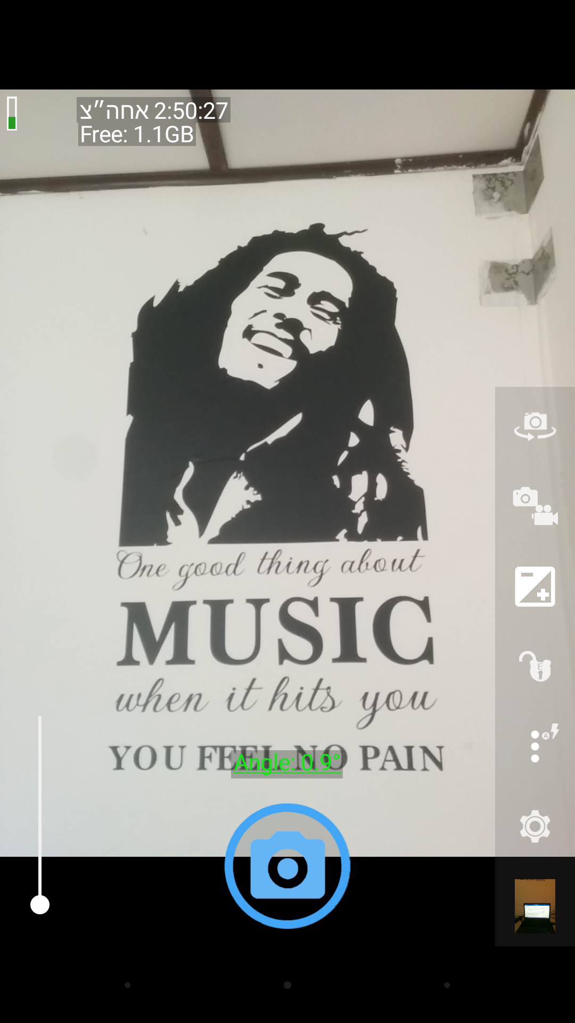

Timer Burst

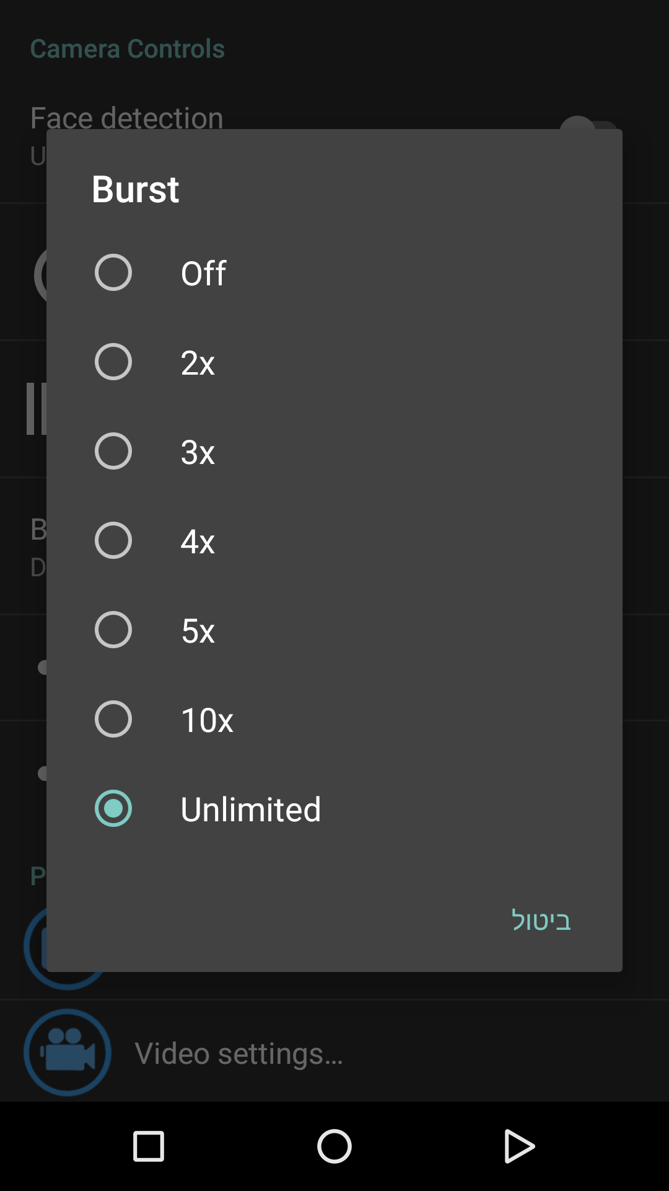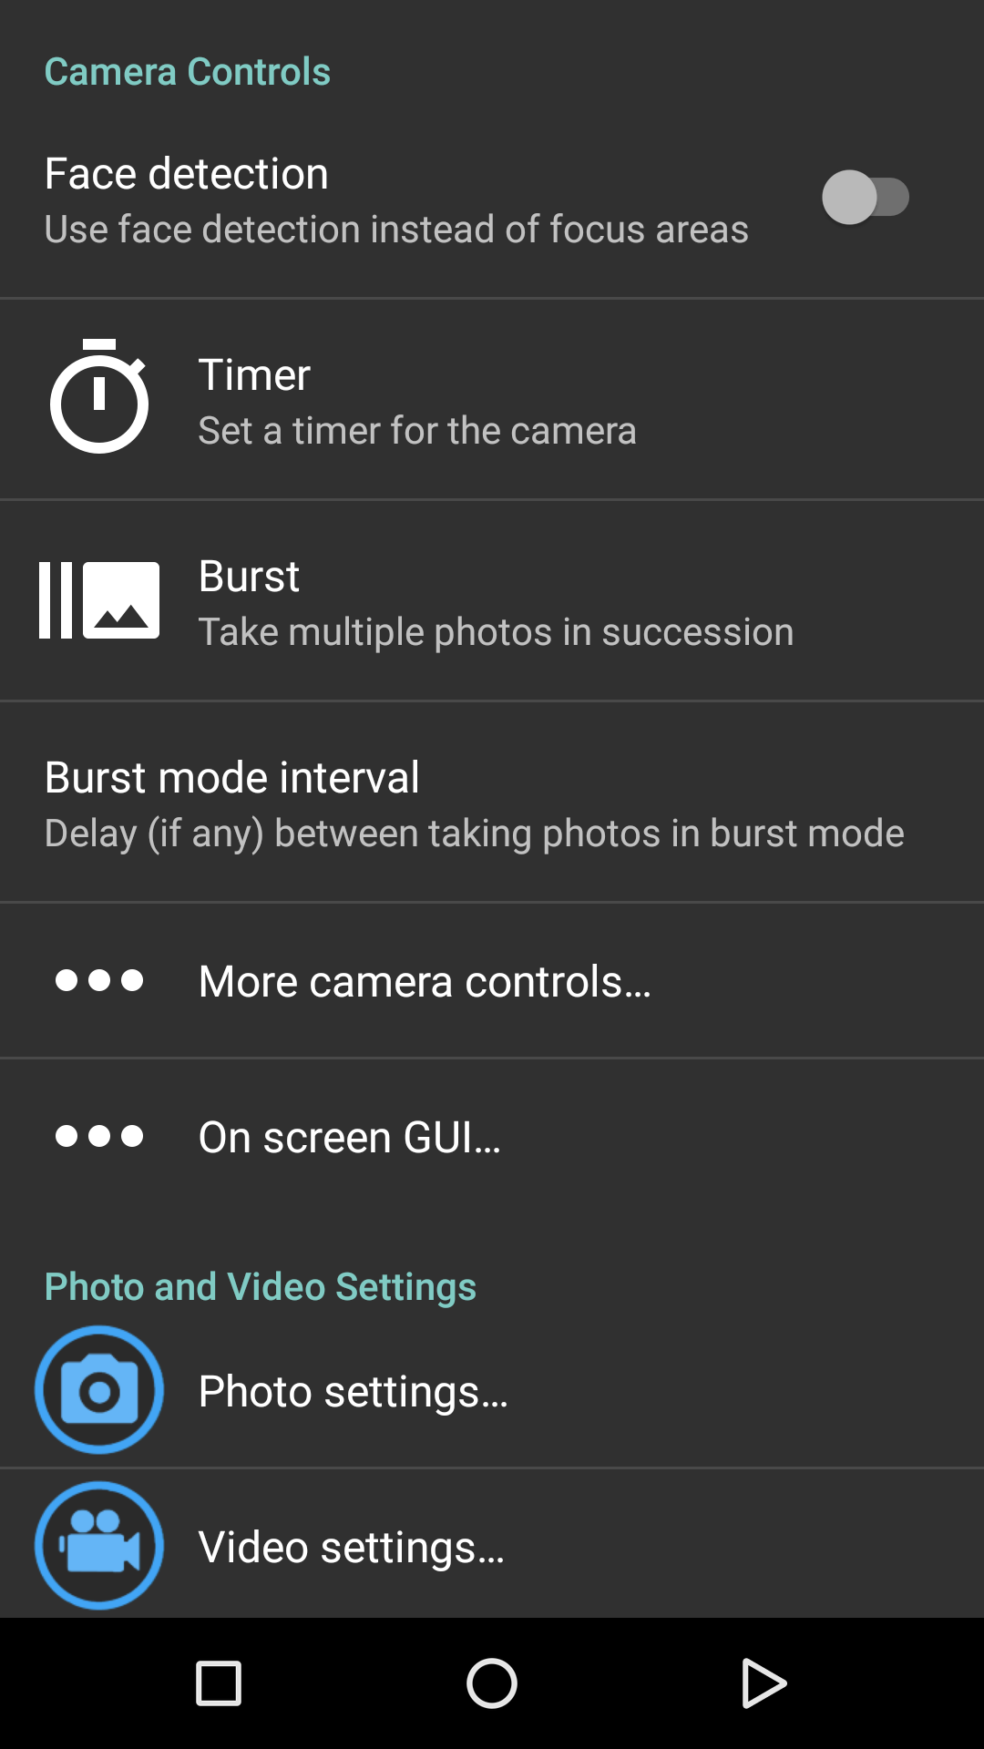

Google Photos:

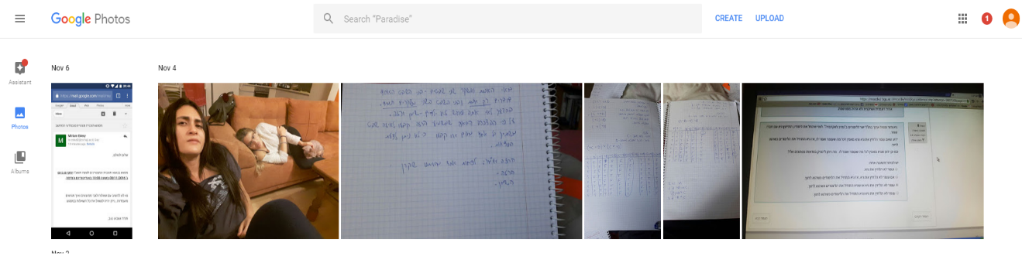

This screenshot shows my saved photos in google photos on my computer.

Sources:

* <https://balloonnews.wordpress.com/2014/04/10/10-ways-that-a-high-altitude-balloon-flight-can-go-wrong/>
* <http://www.highaltitudescience.com/pages/frequently-asked-questions#7>
* Link to open source: <http://opencamera.sourceforge.net/>